# **Name: Abdurrahman Qureshi**

# **Roll No: 210451**

Practical No: 14

**1)Perform automation testing on MS Paint via Auto-IT**

**a) Create Objects in Paint.**

**CODE:**

Run("mspaint.exe")

WinWaitActive("Untitled - Paint")

Sleep(200)

MouseClick("left", 630, 150, 1)

Sleep(300)

MouseClickDrag("left", 350, 300, 550, 500, 4)

Sleep(300)

MouseClick("left", 550, 150, 1)

Sleep(300)

MouseClickDrag("left", 400, 380, 500, 480, 4)

**OUTPUT:**

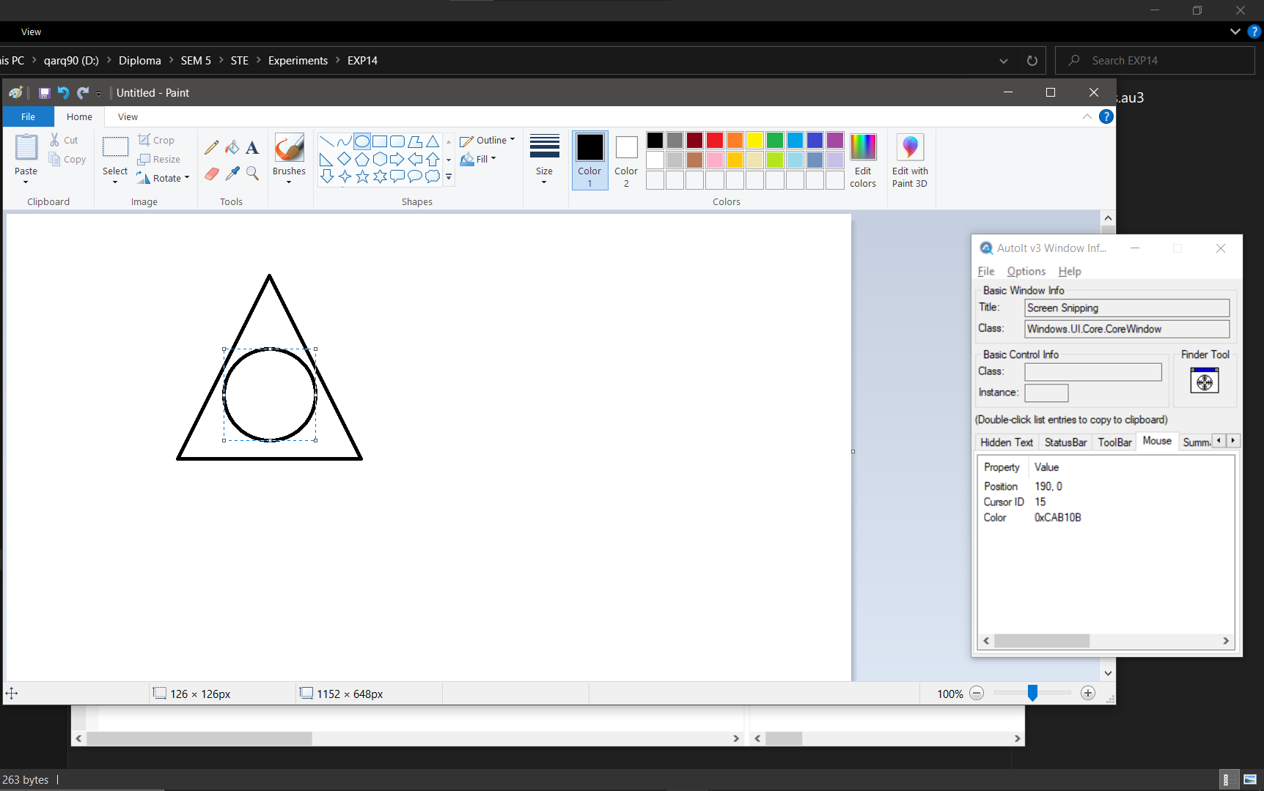

**b) Rotate an object**

**CODE:**

Run("mspaint.exe")

WinWaitActive("Untitled - Paint")

Sleep(200)

MouseClick("left", 630, 150, 1)

Sleep(300)

MouseClickDrag("left", 260, 330, 435, 523, 4)

Sleep(300)

MouseClick("left", 330, 190, 1)

Sleep(300)

MouseClick("left", 360, 235, 1)

**OUTPUT:**

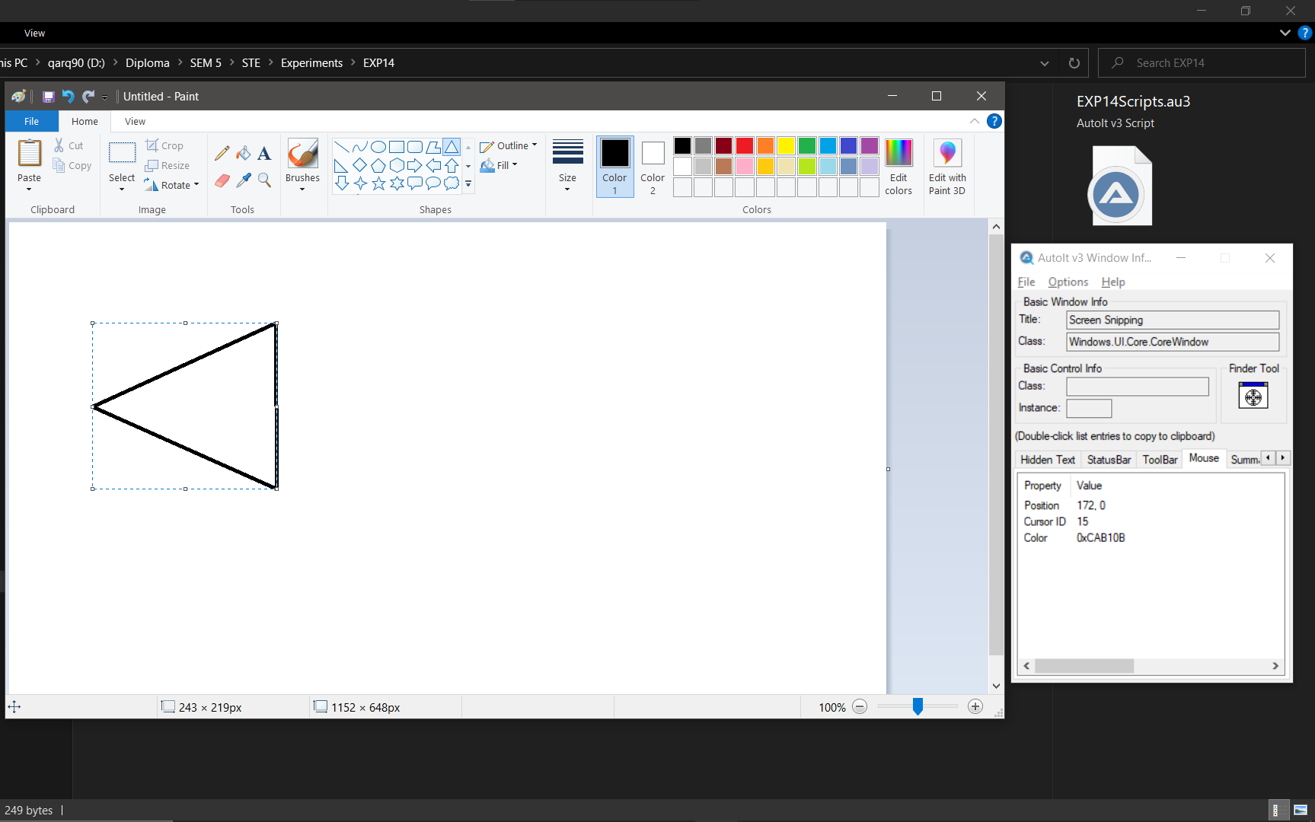

1. **Fill the rotated shape**

**CODE:**

Run("mspaint.exe")

WinWaitActive("Untitled - Paint")

Sleep(200)

MouseClick("left", 630, 150, 1)

Sleep(300)

MouseClickDrag("left", 260, 330, 435, 523, 4)

Sleep(300)

MouseClick("left", 330, 190, 1)

Sleep(300)

MouseClick("left", 360, 235, 1)

Sleep(300)

MouseClick("left", 410, 156, 1)

Sleep(300)

MouseClick("left",1000,150,1)

Sleep(300)

MouseClick("left",400,420,1)

**OUTPUT:**

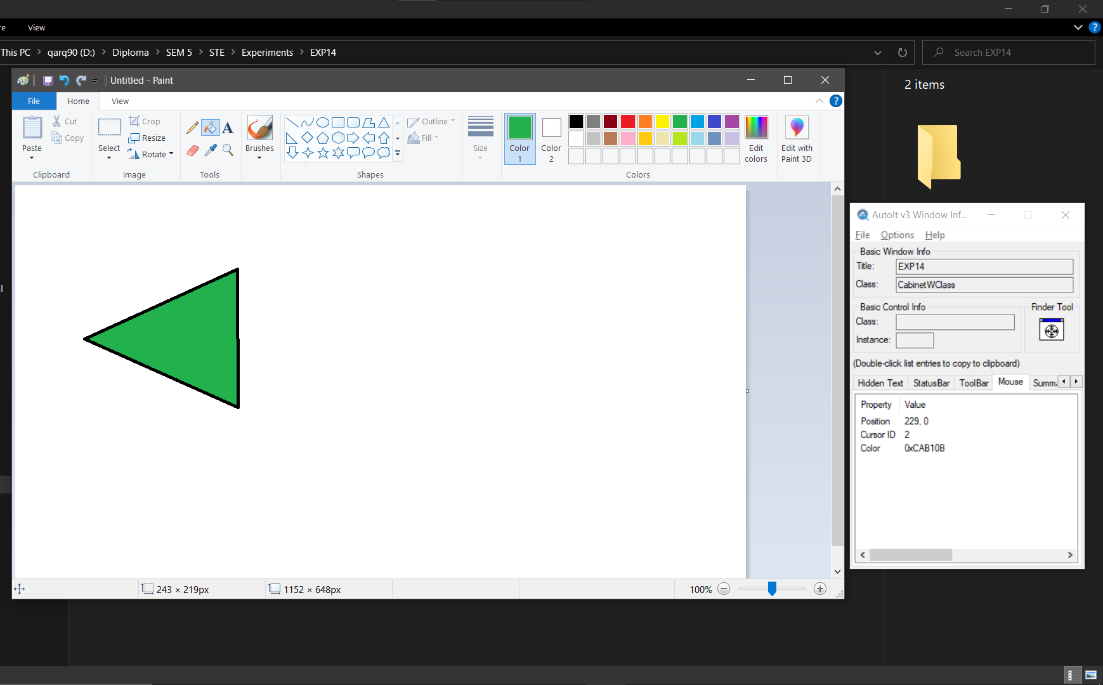

**2)Perform automation testing on Calculator via Auto-IT**

**CODE:**

Run("calc.exe")

WinWaitActive("Calculator")

Sleep(500)

Send("50+1=")

Sleep(5000)

Send("2010-5")

Sleep(5000)

Send("1*17=")

Sleep(5000)

Send("7/1=")

**OUTPUT:**

